create a travel plan. I would like to plan a trip for two people to travel to Charleston SC for five days. During that time we would like to see the ocean, and look for antiques. Please provide three ways of traveling there from Knoxville TN, and back with a itinerary, and costs.

Hello! I'd be happy to help you plan a trip to Charleston. With its beautiful beaches and rich history, it sounds like a wonderful destination for you and your companion. Based on your interests in the ocean and antiques, I've created a five-day itinerary with three different travel options and estimated costs.

### **Travel Options from Knoxville, TN to Charleston, SC**

**Driving (Most Cost-Effective and Flexible):**

**Distance/Time:** The drive is approximately 375 miles and takes about 6.5 to 7 hours without stops.

**Cost:** The estimated cost for gas and tolls would be around $70-$100 for a round trip. This is the most budget-friendly option and gives you the freedom to explore at your own pace once you're there.

**Flying (Fastest Option):**

**Distance/Time:** The flight time is roughly 2.5 hours, but you'll need to factor in time for travel to and from the airports, security, and boarding. Flights from Knoxville (TYS) to Charleston (CHS) often have layovers, so the total travel time can be longer.

**Cost:** A round-trip flight per person can range from around $250 to $400+. For two people, you could expect to pay between $500 and $800+.

**Bus (Longest and Least Direct):**

**Distance/Time:** A bus trip from Knoxville to Charleston is a long journey, often with multiple transfers. The travel time can be upwards of 18 hours.

**Cost:** This can be a very affordable option, with round-trip tickets potentially as low as $150 per person. However, the lengthy travel time and limited flexibility may not be ideal for a shorter five-day trip.

### **Charleston, SC Itinerary for 5 Days**

This itinerary is designed to balance your interests in the ocean and antique hunting while also allowing time to explore Charleston's other attractions.

**Day 1: Arrival and Historic Charm**

**Morning/Afternoon:** Arrive in Charleston via your chosen travel method. Check into your hotel.

**Late Afternoon:** Begin your exploration with a walk through the historic downtown area. Stroll along **Rainbow Row**, a series of colorful historic houses, and the beautiful **Waterfront Park**, home to the iconic Pineapple Fountain.

**Evening:** Enjoy a classic Southern dinner at a restaurant in the historic district.

**Day 2: Beach Day on the Atlantic Coast**

**Morning:** Take a short drive to one of the nearby beaches. **Folly Beach** is known for its lively, laid-back vibe and surfing, while **Isle of Palms** offers a more family-friendly and relaxed atmosphere. **Sullivan's Island** is another great option for a quieter beach experience.

**Afternoon:** Spend the afternoon relaxing on the sand, swimming in the ocean, or walking along the shore searching for seashells.

**Evening:** Have a casual dinner at a beachfront restaurant and watch the sunset.

**Day 3: Antique Shopping on King Street**

**Morning:** Head to the **King Street Antiques District**. This area is a treasure trove of antique shops and boutiques. You'll find a wide variety of items, from fine furniture and jewelry to unique collectibles.

**Afternoon:** Continue your antique hunt, and be sure to visit some of the well-known establishments like **Croghan's Jewel Box** for estate jewelry or **Birlant & Co.** for 18th and 19th-century English antiques.

**Evening:** Enjoy a more upscale dining experience on King Street.

**Day 4: History and Exploration**

**Morning:** Dive into Charleston's history with a visit to a significant landmark. You could take a boat tour to **Fort Sumter National Monument**, where the first shots of the Civil War were fired, or visit one of the historic plantations outside the city, such as **Boone Hall Plantation**.

**Afternoon:** Back in the city, consider a horse-drawn carriage tour to get a different perspective on the historic streets and learn more about the city's past.

**Evening:** Savor a final memorable dinner, perhaps trying a different local cuisine like Lowcountry barbecue.

**Day 5: Departure**

**Morning:** Before you head out, grab a quick breakfast and do some last-minute souvenir shopping at the **Charleston City Market**, where local vendors sell everything from handmade sweetgrass baskets to art and food.

**Afternoon:** Begin your journey home.

### **Estimated Trip Costs for 5 Days (for two people)**

These are general estimates and can vary greatly depending on your choices.

**Accommodation:**

**Mid-range hotel:** $200 - $400 per night, for a total of $800 - $1600.

**Budget-friendly:** Could be as low as $150 per night, for a total of $600+.

**Food:**

**Estimated daily cost:** $100 - $150 per day for two people, for a total of $500 - $750.

**Activities & Sightseeing:**

**Estimated cost:** $200 - $300 for tours, museum admissions, and other activities.

**Transportation (In-City):**

**Rental car:** If you don't drive your own car, a rental could be around $250 - $400 for the five days. Taxis or ride-sharing services are another option.

**Parking:** Be aware that parking in downtown Charleston can be expensive.

**Total Estimated Cost (excluding travel to/from Charleston):** $1500 - $3000+

I hope this gives you a great starting point for planning your trip! If you have any questions or would like to adjust the itinerary, please let me know. I'm here to help.

Is there hotels close to the beach, and if what would be the costs off season?

Google Hotels

Google Hotels

3 successful queries

Based on a five-day stay in late October, which is considered off-season, here are some hotel options near the beaches of Charleston, SC:

**Folly Beach:**

**Tides Folly Beach:** A 3-star oceanfront hotel with a nightly price of approximately $177 and a total stay price of $887. It has an excellent review rating of 4.3 out of 5.

**The Palms Oceanfront Hotel:** Another 3-star oceanfront option, with a nightly price of about $145 and a total stay price of $727. It has a review rating of 4.0 out of 5.

**Isle of Palms:**

**The Palms Oceanfront Hotel:** The same hotel listed for Folly Beach is also a good option for Isle of Palms. The price is about $145 per night for a total of $727.

**Seaside Inn:** A 3-star hotel with direct beach access. The nightly price is around $167, and the total stay price is $835.

**Sullivan's Island:**

This is a quieter, more residential beach area with fewer hotels directly on the island. The search results returned hotels in nearby Mount Pleasant.

**Homewood Suites by Hilton Charleston - Mt. Pleasant:** A 3-star hotel with a nightly price of about $109 and a total stay price of $546. This hotel is a short drive from Sullivan's Island.

The prices listed are for a five-night stay from October 27th to November 1st, 2025, and are for two adults. Keep in mind that prices can vary based on the exact dates, availability, and specific hotel. You can get a better deal during the off-season.

[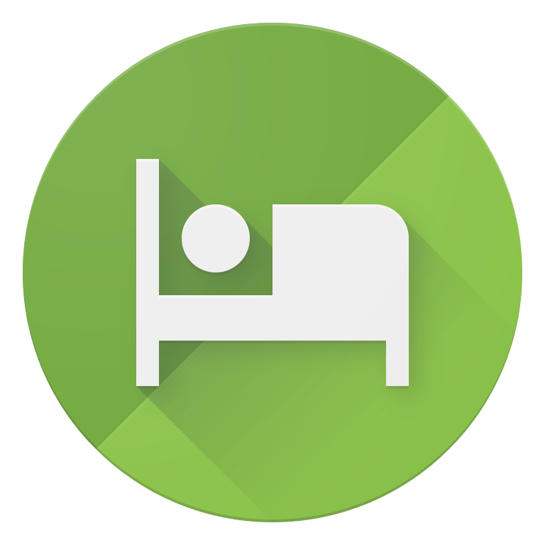](" \t "_blank)

[Google Hotels](" \t "_blank)

[Hotels near Folly Beach, Charleston, SC · Oct 27 - Nov 1 · 2 adults](" \t "_blank)

[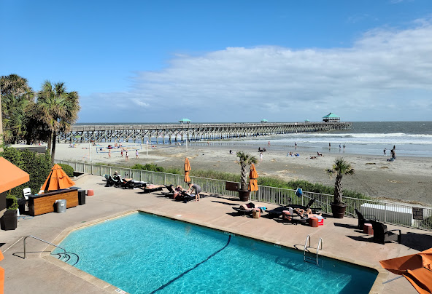](https://www.google.com/travel/search?q=Tides+Folly+Beach,+Charleston's+Oceanfront+Hotel&qs=MhNDZ29JZ19pZ3c1cTgtSWtwRUFF&ts=CAESCAoCCAMKAggDGhYSFBISCgcI6Q8QChgbEgcI6Q8QCxgBKgcKBToDVVNE" \t "_blank)

[Tides Folly Beach, Charleston's Oceanfront Hotel4.3 (3718) • 3-star hotel](https://www.google.com/travel/search?q=Tides+Folly+Beach,+Charleston's+Oceanfront+Hotel&qs=MhNDZ29JZ19pZ3c1cTgtSWtwRUFF&ts=CAESCAoCCAMKAggDGhYSFBISCgcI6Q8QChgbEgcI6Q8QCxgBKgcKBToDVVNE" \t "_blank)

[$177/night](https://www.google.com/travel/search?q=Tides+Folly+Beach,+Charleston's+Oceanfront+Hotel&qs=MhNDZ29JZ19pZ3c1cTgtSWtwRUFF&ts=CAESCAoCCAMKAggDGhYSFBISCgcI6Q8QChgbEgcI6Q8QCxgBKgcKBToDVVNE" \t "_blank)

[Trendy, oceanfront hotel featuring bright, modern rooms, an outdoor pool & a seafood restaurant.](https://www.google.com/travel/search?q=Tides+Folly+Beach,+Charleston's+Oceanfront+Hotel&qs=MhNDZ29JZ19pZ3c1cTgtSWtwRUFF&ts=CAESCAoCCAMKAggDGhYSFBISCgcI6Q8QChgbEgcI6Q8QCxgBKgcKBToDVVNE" \t "_blank)

[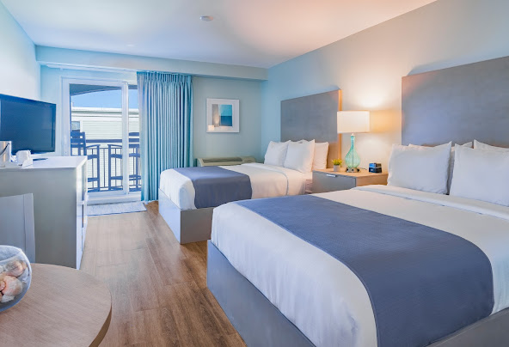](https://www.google.com/travel/search?q=The+Palms+Oceanfront+Hotel&qs=MhNDZ29JMWFUMjZNT2FrWmRmRUFF&ts=CAESCAoCCAMKAggDGhYSFBISCgcI6Q8QChgbEgcI6Q8QCxgBKgcKBToDVVNE" \t "_blank)

[The Palms Oceanfront Hotel4 (753) • 3-star hotel](https://www.google.com/travel/search?q=The+Palms+Oceanfront+Hotel&qs=MhNDZ29JMWFUMjZNT2FrWmRmRUFF&ts=CAESCAoCCAMKAggDGhYSFBISCgcI6Q8QChgbEgcI6Q8QCxgBKgcKBToDVVNE" \t "_blank)

[$145/night](https://www.google.com/travel/search?q=The+Palms+Oceanfront+Hotel&qs=MhNDZ29JMWFUMjZNT2FrWmRmRUFF&ts=CAESCAoCCAMKAggDGhYSFBISCgcI6Q8QChgbEgcI6Q8QCxgBKgcKBToDVVNE" \t "_blank)

[Simple hotel with beach access featuring a pool & a sundeck, plus breakfast & Wi-Fi.](https://www.google.com/travel/search?q=The+Palms+Oceanfront+Hotel&qs=MhNDZ29JMWFUMjZNT2FrWmRmRUFF&ts=CAESCAoCCAMKAggDGhYSFBISCgcI6Q8QChgbEgcI6Q8QCxgBKgcKBToDVVNE" \t "_blank)

[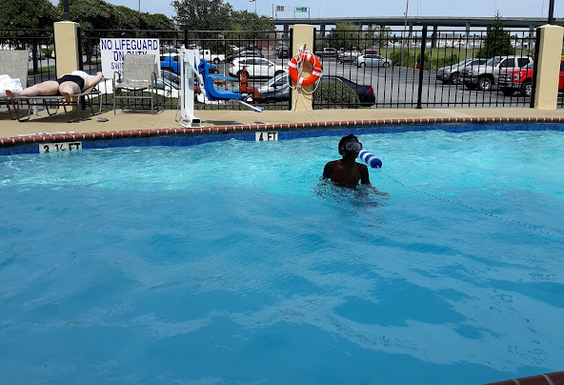](https://www.google.com/travel/search?q=La+Quinta+Inn+&+Suites+by+Wyndham+Charleston+Riverview&qs=MhRDZ3NJMDUyaTZzNjk0dmVlQVJBQg&ts=CAESCAoCCAMKAggDGhYSFBISCgcI6Q8QChgbEgcI6Q8QCxgBKgcKBToDVVNE" \t "_blank)

[La Quinta Inn & Suites by Wyndham Charleston Riverview3.2 (2271) • 3-star hotel](https://www.google.com/travel/search?q=La+Quinta+Inn+&+Suites+by+Wyndham+Charleston+Riverview&qs=MhRDZ3NJMDUyaTZzNjk0dmVlQVJBQg&ts=CAESCAoCCAMKAggDGhYSFBISCgcI6Q8QChgbEgcI6Q8QCxgBKgcKBToDVVNE" \t "_blank)

[$58/night](https://www.google.com/travel/search?q=La+Quinta+Inn+&+Suites+by+Wyndham+Charleston+Riverview&qs=MhRDZ3NJMDUyaTZzNjk0dmVlQVJBQg&ts=CAESCAoCCAMKAggDGhYSFBISCgcI6Q8QChgbEgcI6Q8QCxgBKgcKBToDVVNE" \t "_blank)

[Casual lodging with an outdoor pool, plus free continental breakfast & WiFi.](https://www.google.com/travel/search?q=La+Quinta+Inn+&+Suites+by+Wyndham+Charleston+Riverview&qs=MhRDZ3NJMDUyaTZzNjk0dmVlQVJBQg&ts=CAESCAoCCAMKAggDGhYSFBISCgcI6Q8QChgbEgcI6Q8QCxgBKgcKBToDVVNE" \t "_blank)

[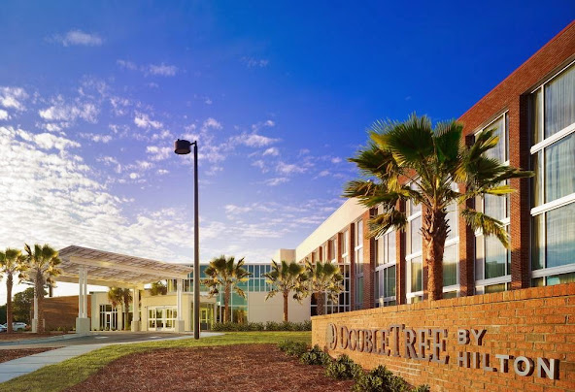](https://www.google.com/travel/search?q=DoubleTree+by+Hilton+Hotel+&+Suites+Charleston+Airport&qs=MhRDZ3NJdUx1U2ljRFF5dVRJQVJBQg&ts=CAESCAoCCAMKAggDGhYSFBISCgcI6Q8QChgbEgcI6Q8QCxgBKgcKBToDVVNE" \t "_blank)

[DoubleTree by Hilton Hotel & Suites Charleston Airport4.2 (1425) • 3-star hotel](https://www.google.com/travel/search?q=DoubleTree+by+Hilton+Hotel+&+Suites+Charleston+Airport&qs=MhRDZ3NJdUx1U2ljRFF5dVRJQVJBQg&ts=CAESCAoCCAMKAggDGhYSFBISCgcI6Q8QChgbEgcI6Q8QCxgBKgcKBToDVVNE" \t "_blank)

[$116/night](https://www.google.com/travel/search?q=DoubleTree+by+Hilton+Hotel+&+Suites+Charleston+Airport&qs=MhRDZ3NJdUx1U2ljRFF5dVRJQVJBQg&ts=CAESCAoCCAMKAggDGhYSFBISCgcI6Q8QChgbEgcI6Q8QCxgBKgcKBToDVVNE" \t "_blank)

[Contemporary decor & an industrial-chic restaurant, plus an outdoor pool & free airport shuttle.](https://www.google.com/travel/search?q=DoubleTree+by+Hilton+Hotel+&+Suites+Charleston+Airport&qs=MhRDZ3NJdUx1U2ljRFF5dVRJQVJBQg&ts=CAESCAoCCAMKAggDGhYSFBISCgcI6Q8QChgbEgcI6Q8QCxgBKgcKBToDVVNE" \t "_blank)

[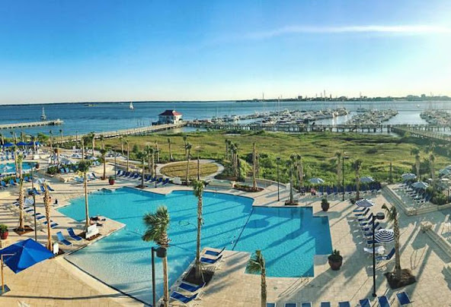](https://www.google.com/travel/search?q=Charleston+Harbor+Resort+&+Marina&qs=MhRDZ3NJa1lmM3RNLVhvcG01QVJBQg&ts=CAESCAoCCAMKAggDGhYSFBISCgcI6Q8QChgbEgcI6Q8QCxgBKgcKBToDVVNE" \t "_blank)

[Charleston Harbor Resort & Marina4.1 (2349) • 4-star hotel](https://www.google.com/travel/search?q=Charleston+Harbor+Resort+&+Marina&qs=MhRDZ3NJa1lmM3RNLVhvcG01QVJBQg&ts=CAESCAoCCAMKAggDGhYSFBISCgcI6Q8QChgbEgcI6Q8QCxgBKgcKBToDVVNE" \t "_blank)

[$256/night](https://www.google.com/travel/search?q=Charleston+Harbor+Resort+&+Marina&qs=MhRDZ3NJa1lmM3RNLVhvcG01QVJBQg&ts=CAESCAoCCAMKAggDGhYSFBISCgcI6Q8QChgbEgcI6Q8QCxgBKgcKBToDVVNE" \t "_blank)

[Nautical-themed rooms, some with harbour views, in resort with dining, a marina & recreation.](https://www.google.com/travel/search?q=Charleston+Harbor+Resort+&+Marina&qs=MhRDZ3NJa1lmM3RNLVhvcG01QVJBQg&ts=CAESCAoCCAMKAggDGhYSFBISCgcI6Q8QChgbEgcI6Q8QCxgBKgcKBToDVVNE" \t "_blank)

[](" \t "_blank)

[Google Hotels](" \t "_blank)

[Hotels near Isle of Palms, Charleston, SC · Oct 27 - Nov 1 · 2 adults](" \t "_blank)

[](https://www.google.com/travel/search?q=The+Palms+Oceanfront+Hotel&qs=MhNDZ29JMWFUMjZNT2FrWmRmRUFF&ts=CAESCAoCCAMKAggDGhYSFBISCgcI6Q8QChgbEgcI6Q8QCxgBKgcKBToDVVNE" \t "_blank)

[The Palms Oceanfront Hotel4 (753) • 3-star hotel](https://www.google.com/travel/search?q=The+Palms+Oceanfront+Hotel&qs=MhNDZ29JMWFUMjZNT2FrWmRmRUFF&ts=CAESCAoCCAMKAggDGhYSFBISCgcI6Q8QChgbEgcI6Q8QCxgBKgcKBToDVVNE" \t "_blank)

[$145/night](https://www.google.com/travel/search?q=The+Palms+Oceanfront+Hotel&qs=MhNDZ29JMWFUMjZNT2FrWmRmRUFF&ts=CAESCAoCCAMKAggDGhYSFBISCgcI6Q8QChgbEgcI6Q8QCxgBKgcKBToDVVNE" \t "_blank)

[Simple hotel with beach access featuring a pool & a sundeck, plus breakfast & Wi-Fi.](https://www.google.com/travel/search?q=The+Palms+Oceanfront+Hotel&qs=MhNDZ29JMWFUMjZNT2FrWmRmRUFF&ts=CAESCAoCCAMKAggDGhYSFBISCgcI6Q8QChgbEgcI6Q8QCxgBKgcKBToDVVNE" \t "_blank)

[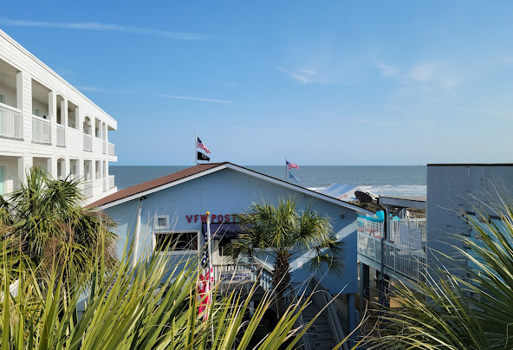](https://www.google.com/travel/search?q=Seaside+Inn&qs=MhNDZ29JemNXc3FZNjR5LXNSRUFF&ts=CAESCAoCCAMKAggDGhYSFBISCgcI6Q8QChgbEgcI6Q8QCxgBKgcKBToDVVNE" \t "_blank)

[Seaside Inn3.6 (729) • 3-star hotel](https://www.google.com/travel/search?q=Seaside+Inn&qs=MhNDZ29JemNXc3FZNjR5LXNSRUFF&ts=CAESCAoCCAMKAggDGhYSFBISCgcI6Q8QChgbEgcI6Q8QCxgBKgcKBToDVVNE" \t "_blank)

[$167/night](https://www.google.com/travel/search?q=Seaside+Inn&qs=MhNDZ29JemNXc3FZNjR5LXNSRUFF&ts=CAESCAoCCAMKAggDGhYSFBISCgcI6Q8QChgbEgcI6Q8QCxgBKgcKBToDVVNE" \t "_blank)

[Relaxed retreat with direct beach access, plus a top-floor pool & a kids' playground.](https://www.google.com/travel/search?q=Seaside+Inn&qs=MhNDZ29JemNXc3FZNjR5LXNSRUFF&ts=CAESCAoCCAMKAggDGhYSFBISCgcI6Q8QChgbEgcI6Q8QCxgBKgcKBToDVVNE" \t "_blank)

[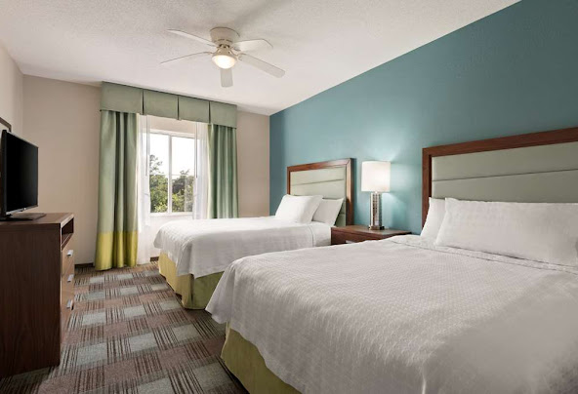](https://www.google.com/travel/search?q=Homewood+Suites+by+Hilton+Charleston+-+Mt.+Pleasant&qs=MhNDZ29JenFfeGxiMkF3LUkxRUFF&ts=CAESCAoCCAMKAggDGhYSFBISCgcI6Q8QChgbEgcI6Q8QCxgBKgcKBToDVVNE" \t "_blank)

[Homewood Suites by Hilton Charleston - Mt. Pleasant4.1 (795) • 3-star hotel](https://www.google.com/travel/search?q=Homewood+Suites+by+Hilton+Charleston+-+Mt.+Pleasant&qs=MhNDZ29JenFfeGxiMkF3LUkxRUFF&ts=CAESCAoCCAMKAggDGhYSFBISCgcI6Q8QChgbEgcI6Q8QCxgBKgcKBToDVVNE" \t "_blank)

[$109/night](https://www.google.com/travel/search?q=Homewood+Suites+by+Hilton+Charleston+-+Mt.+Pleasant&qs=MhNDZ29JenFfeGxiMkF3LUkxRUFF&ts=CAESCAoCCAMKAggDGhYSFBISCgcI6Q8QChgbEgcI6Q8QCxgBKgcKBToDVVNE" \t "_blank)

[Contemporary extended-stay hotel offering suites with kitchens & Wi-Fi, plus an outdoor pool.](https://www.google.com/travel/search?q=Homewood+Suites+by+Hilton+Charleston+-+Mt.+Pleasant&qs=MhNDZ29JenFfeGxiMkF3LUkxRUFF&ts=CAESCAoCCAMKAggDGhYSFBISCgcI6Q8QChgbEgcI6Q8QCxgBKgcKBToDVVNE" \t "_blank)

[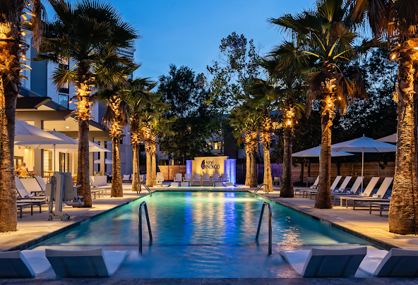](https://www.google.com/travel/search?q=Hotel+Indigo+Mount+Pleasant,+an+IHG+Hotel&qs=MhNDZ29JdnNEX3U5LU1scWxYRUFF&ts=CAESCAoCCAMKAggDGhYSFBISCgcI6Q8QChgbEgcI6Q8QCxgBKgcKBToDVVNE" \t "_blank)

[Hotel Indigo Mount Pleasant, an IHG Hotel4.2 (1031) • 3-star hotel](https://www.google.com/travel/search?q=Hotel+Indigo+Mount+Pleasant,+an+IHG+Hotel&qs=MhNDZ29JdnNEX3U5LU1scWxYRUFF&ts=CAESCAoCCAMKAggDGhYSFBISCgcI6Q8QChgbEgcI6Q8QCxgBKgcKBToDVVNE" \t "_blank)

[$151/night](https://www.google.com/travel/search?q=Hotel+Indigo+Mount+Pleasant,+an+IHG+Hotel&qs=MhNDZ29JdnNEX3U5LU1scWxYRUFF&ts=CAESCAoCCAMKAggDGhYSFBISCgcI6Q8QChgbEgcI6Q8QCxgBKgcKBToDVVNE" \t "_blank)

[Casual hotel offering an outdoor pool & a contemporary restaurant, plus free Wi-Fi & parking.](https://www.google.com/travel/search?q=Hotel+Indigo+Mount+Pleasant,+an+IHG+Hotel&qs=MhNDZ29JdnNEX3U5LU1scWxYRUFF&ts=CAESCAoCCAMKAggDGhYSFBISCgcI6Q8QChgbEgcI6Q8QCxgBKgcKBToDVVNE" \t "_blank)

[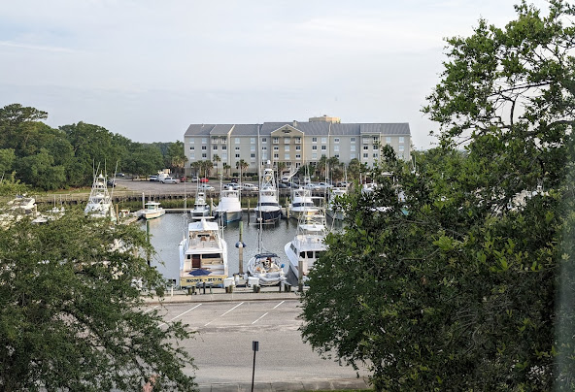](https://www.google.com/travel/search?q=La+Quinta+Inn+&+Suites+by+Wyndham+Charleston+Riverview&qs=MhRDZ3NJMDUyaTZzNjk0dmVlQVJBQg&ts=CAESCAoCCAMKAggDGhYSFBISCgcI6Q8QChgbEgcI6Q8QCxgBKgcKBToDVVNE" \t "_blank)

[La Quinta Inn & Suites by Wyndham Charleston Riverview3.2 (2271) • 3-star hotel](https://www.google.com/travel/search?q=La+Quinta+Inn+&+Suites+by+Wyndham+Charleston+Riverview&qs=MhRDZ3NJMDUyaTZzNjk0dmVlQVJBQg&ts=CAESCAoCCAMKAggDGhYSFBISCgcI6Q8QChgbEgcI6Q8QCxgBKgcKBToDVVNE" \t "_blank)

[$58/night](https://www.google.com/travel/search?q=La+Quinta+Inn+&+Suites+by+Wyndham+Charleston+Riverview&qs=MhRDZ3NJMDUyaTZzNjk0dmVlQVJBQg&ts=CAESCAoCCAMKAggDGhYSFBISCgcI6Q8QChgbEgcI6Q8QCxgBKgcKBToDVVNE" \t "_blank)

[Casual lodging with an outdoor pool, plus free continental breakfast & WiFi.](https://www.google.com/travel/search?q=La+Quinta+Inn+&+Suites+by+Wyndham+Charleston+Riverview&qs=MhRDZ3NJMDUyaTZzNjk0dmVlQVJBQg&ts=CAESCAoCCAMKAggDGhYSFBISCgcI6Q8QChgbEgcI6Q8QCxgBKgcKBToDVVNE" \t "_blank)

[](" \t "_blank)

[Google Hotels](" \t "_blank)

[Hotels near Sullivan's Island, Charleston, SC · Oct 27 - Nov 1 · 2 adults](" \t "_blank)

[](https://www.google.com/travel/search?q=The+Palms+Oceanfront+Hotel&qs=MhNDZ29JMWFUMjZNT2FrWmRmRUFF&ts=CAESCAoCCAMKAggDGhYSFBISCgcI6Q8QChgbEgcI6Q8QCxgBKgcKBToDVVNE" \t "_blank)

[The Palms Oceanfront Hotel4 (753) • 3-star hotel](https://www.google.com/travel/search?q=The+Palms+Oceanfront+Hotel&qs=MhNDZ29JMWFUMjZNT2FrWmRmRUFF&ts=CAESCAoCCAMKAggDGhYSFBISCgcI6Q8QChgbEgcI6Q8QCxgBKgcKBToDVVNE" \t "_blank)

[$145/night](https://www.google.com/travel/search?q=The+Palms+Oceanfront+Hotel&qs=MhNDZ29JMWFUMjZNT2FrWmRmRUFF&ts=CAESCAoCCAMKAggDGhYSFBISCgcI6Q8QChgbEgcI6Q8QCxgBKgcKBToDVVNE" \t "_blank)

[Simple hotel with beach access featuring a pool & a sundeck, plus breakfast & Wi-Fi.](https://www.google.com/travel/search?q=The+Palms+Oceanfront+Hotel&qs=MhNDZ29JMWFUMjZNT2FrWmRmRUFF&ts=CAESCAoCCAMKAggDGhYSFBISCgcI6Q8QChgbEgcI6Q8QCxgBKgcKBToDVVNE" \t "_blank)

[](https://www.google.com/travel/search?q=Homewood+Suites+by+Hilton+Charleston+-+Mt.+Pleasant&qs=MhNDZ29JenFfeGxiMkF3LUkxRUFF&ts=CAESCAoCCAMKAggDGhYSFBISCgcI6Q8QChgbEgcI6Q8QCxgBKgcKBToDVVNE" \t "_blank)

[Homewood Suites by Hilton Charleston - Mt. Pleasant4.1 (795) • 3-star hotel](https://www.google.com/travel/search?q=Homewood+Suites+by+Hilton+Charleston+-+Mt.+Pleasant&qs=MhNDZ29JenFfeGxiMkF3LUkxRUFF&ts=CAESCAoCCAMKAggDGhYSFBISCgcI6Q8QChgbEgcI6Q8QCxgBKgcKBToDVVNE" \t "_blank)

[$109/night](https://www.google.com/travel/search?q=Homewood+Suites+by+Hilton+Charleston+-+Mt.+Pleasant&qs=MhNDZ29JenFfeGxiMkF3LUkxRUFF&ts=CAESCAoCCAMKAggDGhYSFBISCgcI6Q8QChgbEgcI6Q8QCxgBKgcKBToDVVNE" \t "_blank)

[Contemporary extended-stay hotel offering suites with kitchens & Wi-Fi, plus an outdoor pool.](https://www.google.com/travel/search?q=Homewood+Suites+by+Hilton+Charleston+-+Mt.+Pleasant&qs=MhNDZ29JenFfeGxiMkF3LUkxRUFF&ts=CAESCAoCCAMKAggDGhYSFBISCgcI6Q8QChgbEgcI6Q8QCxgBKgcKBToDVVNE" \t "_blank)

[](https://www.google.com/travel/search?q=Hotel+Indigo+Mount+Pleasant,+an+IHG+Hotel&qs=MhNDZ29JdnNEX3U5LU1scWxYRUFF&ts=CAESCAoCCAMKAggDGhYSFBISCgcI6Q8QChgbEgcI6Q8QCxgBKgcKBToDVVNE" \t "_blank)

[Hotel Indigo Mount Pleasant, an IHG Hotel4.2 (1031) • 3-star hotel](https://www.google.com/travel/search?q=Hotel+Indigo+Mount+Pleasant,+an+IHG+Hotel&qs=MhNDZ29JdnNEX3U5LU1scWxYRUFF&ts=CAESCAoCCAMKAggDGhYSFBISCgcI6Q8QChgbEgcI6Q8QCxgBKgcKBToDVVNE" \t "_blank)

[$151/night](https://www.google.com/travel/search?q=Hotel+Indigo+Mount+Pleasant,+an+IHG+Hotel&qs=MhNDZ29JdnNEX3U5LU1scWxYRUFF&ts=CAESCAoCCAMKAggDGhYSFBISCgcI6Q8QChgbEgcI6Q8QCxgBKgcKBToDVVNE" \t "_blank)

[Casual hotel offering an outdoor pool & a contemporary restaurant, plus free Wi-Fi & parking.](https://www.google.com/travel/search?q=Hotel+Indigo+Mount+Pleasant,+an+IHG+Hotel&qs=MhNDZ29JdnNEX3U5LU1scWxYRUFF&ts=CAESCAoCCAMKAggDGhYSFBISCgcI6Q8QChgbEgcI6Q8QCxgBKgcKBToDVVNE" \t "_blank)

[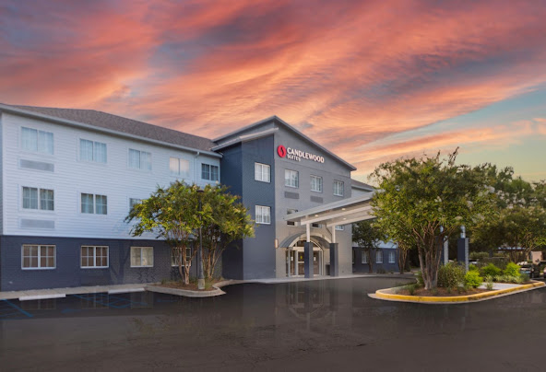](https://www.google.com/travel/search?q=Candlewood+Suites+Charleston+%E2%80%93+Mt.+Pleasant+by+IHG&qs=MhRDZ3NJMnNmTXNOdnNvcFdvQVJBQg&ts=CAESCAoCCAMKAggDGhYSFBISCgcI6Q8QChgbEgcI6Q8QCxgBKgcKBToDVVNE" \t "_blank)

[Candlewood Suites Charleston – Mt. Pleasant by IHG4.3 (238) • 3-star hotel](https://www.google.com/travel/search?q=Candlewood+Suites+Charleston+%E2%80%93+Mt.+Pleasant+by+IHG&qs=MhRDZ3NJMnNmTXNOdnNvcFdvQVJBQg&ts=CAESCAoCCAMKAggDGhYSFBISCgcI6Q8QChgbEgcI6Q8QCxgBKgcKBToDVVNE" \t "_blank)

[$98/night](https://www.google.com/travel/search?q=Candlewood+Suites+Charleston+%E2%80%93+Mt.+Pleasant+by+IHG&qs=MhRDZ3NJMnNmTXNOdnNvcFdvQVJBQg&ts=CAESCAoCCAMKAggDGhYSFBISCgcI6Q8QChgbEgcI6Q8QCxgBKgcKBToDVVNE" \t "_blank)

[Relaxed studios & apartments with kitchens in a low-key hotel featuring a fitness center.](https://www.google.com/travel/search?q=Candlewood+Suites+Charleston+%E2%80%93+Mt.+Pleasant+by+IHG&qs=MhRDZ3NJMnNmTXNOdnNvcFdvQVJBQg&ts=CAESCAoCCAMKAggDGhYSFBISCgcI6Q8QChgbEgcI6Q8QCxgBKgcKBToDVVNE" \t "_blank)

[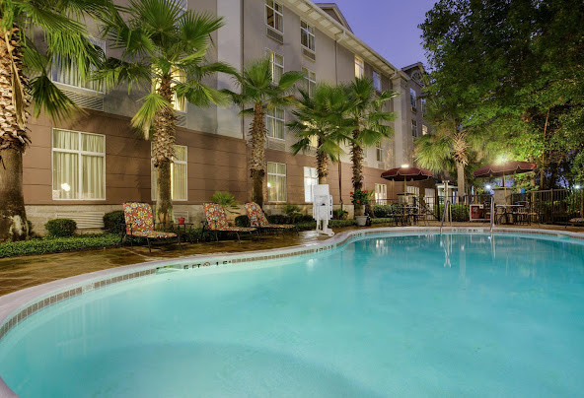](https://www.google.com/travel/search?q=Holiday+Inn+Express+&+Suites+Charleston-Ashley+Phosphate+by+IHG&qs=MhRDZ3NJNmNmRGotYkJfZnVHQVJBQg&ts=CAESCAoCCAMKAggDGhYSFBISCgcI6Q8QChgbEgcI6Q8QCxgBKgcKBToDVVNE" \t "_blank)

[Holiday Inn Express & Suites Charleston-Ashley Phosphate by IHG4.4 (712) • 2-star hotel](https://www.google.com/travel/search?q=Holiday+Inn+Express+&+Suites+Charleston-Ashley+Phosphate+by+IHG&qs=MhRDZ3NJNmNmRGotYkJfZnVHQVJBQg&ts=CAESCAoCCAMKAggDGhYSFBISCgcI6Q8QChgbEgcI6Q8QCxgBKgcKBToDVVNE" \t "_blank)

[$85/night](https://www.google.com/travel/search?q=Holiday+Inn+Express+&+Suites+Charleston-Ashley+Phosphate+by+IHG&qs=MhRDZ3NJNmNmRGotYkJfZnVHQVJBQg&ts=CAESCAoCCAMKAggDGhYSFBISCgcI6Q8QChgbEgcI6Q8QCxgBKgcKBToDVVNE" \t "_blank)

[Straightforward accommodations with an outdoor pool, fitness center & free hot breakfast.](https://www.google.com/travel/search?q=Holiday+Inn+Express+&+Suites+Charleston-Ashley+Phosphate+by+IHG&qs=MhRDZ3NJNmNmRGotYkJfZnVHQVJBQg&ts=CAESCAoCCAMKAggDGhYSFBISCgcI6Q8QChgbEgcI6Q8QCxgBKgcKBToDVVNE" \t "_blank)

Tennessee, USA

My next question would is there hotels close to King Street, and is parking more reasonable closer to King Street or the beach during off season?

Google Hotels

Google Hotels

Query successful

For a stay in late October, which is considered off-season, here are some hotels near King Street in Charleston:

**Courtyard Charleston Waterfront:** A 3-star hotel with a nightly price of approximately $174 and a total stay price of $868 for a 5-night stay. It has a review rating of 4.1 out of 5. This hotel offers free parking, which is a significant saving.

**Moxy Charleston Downtown:** A 3-star hotel with a nightly price of about $205 and a total stay price of $1,023. It has a review rating of 4.0 out of 5.

**Hyatt House Charleston/Historic District:** A 3-star hotel with a nightly price of around $246, with a total stay of $1,229. It has a review rating of 4.2 out of 5.

### Parking Information

Based on off-season rates in late October, parking is generally more reasonable at the beaches.

**King Street:** Parking can be expensive and difficult to find. Garage parking costs approximately $1 per 20 minutes, with a daily maximum of about $24. Street parking meters are active from 9 a.m. to 6 p.m., Monday through Saturday, but are free overnight and on Sundays. Some garages offer discounted evening rates, such as a $5 flat rate after 5 p.m.

**Beaches:** Parking costs at the beaches are lower during the off-season. For example, in November and December, parking at Kiawah Beachwalker Park is a flat rate of $5. At Folly Beach, parking on Center Street and all side streets is free, and paid lots are in effect from 8 a.m. to 10 p.m.

Therefore, for a longer stay, parking would be significantly cheaper at the beach, but less convenient if you plan to spend most of your time exploring King Street. If you stay near King Street, look for a hotel that includes parking to save money.

[](" \t "_blank)

[Google Hotels](" \t "_blank)

[Hotels near King Street, Charleston, SC · Oct 27 - Nov 1 · 2 adults](" \t "_blank)

[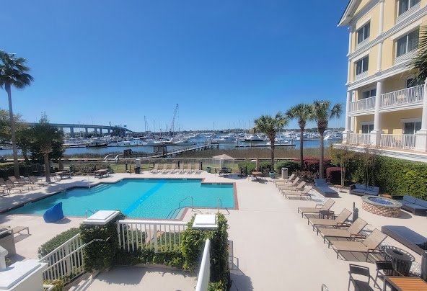](https://www.google.com/travel/search?q=Courtyard+Charleston+Waterfront&qs=MhRDZ3NJZzQyQTlhN2NtcC1zQVJBQg&ts=CAESCAoCCAMKAggDGhYSFBISCgcI6Q8QChgbEgcI6Q8QCxgBKgcKBToDVVNE" \t "_blank)

[Courtyard Charleston Waterfront4.1 (1337) • 3-star hotel](https://www.google.com/travel/search?q=Courtyard+Charleston+Waterfront&qs=MhRDZ3NJZzQyQTlhN2NtcC1zQVJBQg&ts=CAESCAoCCAMKAggDGhYSFBISCgcI6Q8QChgbEgcI6Q8QCxgBKgcKBToDVVNE" \t "_blank)

[$174/night](https://www.google.com/travel/search?q=Courtyard+Charleston+Waterfront&qs=MhRDZ3NJZzQyQTlhN2NtcC1zQVJBQg&ts=CAESCAoCCAMKAggDGhYSFBISCgcI6Q8QChgbEgcI6Q8QCxgBKgcKBToDVVNE" \t "_blank)

[Modern riverfront hotel offering free WiFi & parking, plus an outdoor pool & a courtyard.](https://www.google.com/travel/search?q=Courtyard+Charleston+Waterfront&qs=MhRDZ3NJZzQyQTlhN2NtcC1zQVJBQg&ts=CAESCAoCCAMKAggDGhYSFBISCgcI6Q8QChgbEgcI6Q8QCxgBKgcKBToDVVNE" \t "_blank)

[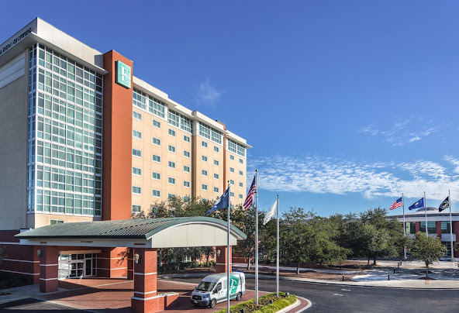](https://www.google.com/travel/search?q=Embassy+Suites+by+Hilton+Charleston+Airport+Hotel+&+Convention+Center&qs=MhRDZ3NJci02ZHhaU05xdG1IQVJBQg&ts=CAESCAoCCAMKAggDGhYSFBISCgcI6Q8QChgbEgcI6Q8QCxgBKgcKBToDVVNE" \t "_blank)

[Embassy Suites by Hilton Charleston Airport Hotel & Convention Center3.9 (2854) • 3-star hotel](https://www.google.com/travel/search?q=Embassy+Suites+by+Hilton+Charleston+Airport+Hotel+&+Convention+Center&qs=MhRDZ3NJci02ZHhaU05xdG1IQVJBQg&ts=CAESCAoCCAMKAggDGhYSFBISCgcI6Q8QChgbEgcI6Q8QCxgBKgcKBToDVVNE" \t "_blank)

[$119/night](https://www.google.com/travel/search?q=Embassy+Suites+by+Hilton+Charleston+Airport+Hotel+&+Convention+Center&qs=MhRDZ3NJci02ZHhaU05xdG1IQVJBQg&ts=CAESCAoCCAMKAggDGhYSFBISCgcI6Q8QChgbEgcI6Q8QCxgBKgcKBToDVVNE" \t "_blank)

[Relaxed all-suite lodging with free breakfast & a restaurant, plus a gym & an indoor pool.](https://www.google.com/travel/search?q=Embassy+Suites+by+Hilton+Charleston+Airport+Hotel+&+Convention+Center&qs=MhRDZ3NJci02ZHhaU05xdG1IQVJBQg&ts=CAESCAoCCAMKAggDGhYSFBISCgcI6Q8QChgbEgcI6Q8QCxgBKgcKBToDVVNE" \t "_blank)

[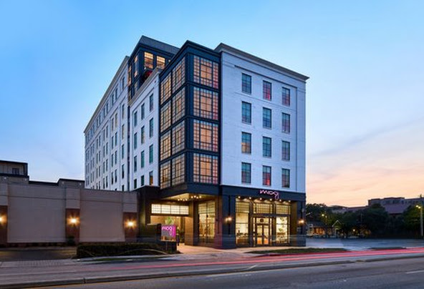](https://www.google.com/travel/search?q=Moxy+Charleston+Downtown&qs=MhNDZ29JaWJfQjQtR2poOWhORUFF&ts=CAESCAoCCAMKAggDGhYSFBISCgcI6Q8QChgbEgcI6Q8QCxgBKgcKBToDVVNE" \t "_blank)

[Moxy Charleston Downtown4 (297) • 3-star hotel](https://www.google.com/travel/search?q=Moxy+Charleston+Downtown&qs=MhNDZ29JaWJfQjQtR2poOWhORUFF&ts=CAESCAoCCAMKAggDGhYSFBISCgcI6Q8QChgbEgcI6Q8QCxgBKgcKBToDVVNE" \t "_blank)

[$205/night](https://www.google.com/travel/search?q=Moxy+Charleston+Downtown&qs=MhNDZ29JaWJfQjQtR2poOWhORUFF&ts=CAESCAoCCAMKAggDGhYSFBISCgcI6Q8QChgbEgcI6Q8QCxgBKgcKBToDVVNE" \t "_blank)

[Hip, colorful rooms in a contemporary hotel with a cozy bar, a 24-hour gym and a rooftop terrace.](https://www.google.com/travel/search?q=Moxy+Charleston+Downtown&qs=MhNDZ29JaWJfQjQtR2poOWhORUFF&ts=CAESCAoCCAMKAggDGhYSFBISCgcI6Q8QChgbEgcI6Q8QCxgBKgcKBToDVVNE" \t "_blank)

[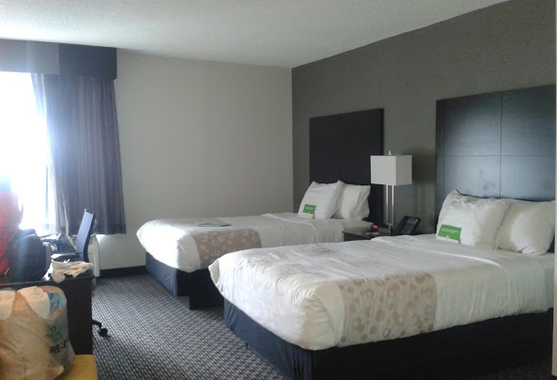](https://www.google.com/travel/search?q=La+Quinta+Inn+&+Suites+by+Wyndham+Charleston+Riverview&qs=MhRDZ3NJMDUyaTZzNjk0dmVlQVJBQg&ts=CAESCAoCCAMKAggDGhYSFBISCgcI6Q8QChgbEgcI6Q8QCxgBKgcKBToDVVNE" \t "_blank)

[La Quinta Inn & Suites by Wyndham Charleston Riverview3.2 (2271) • 3-star hotel](https://www.google.com/travel/search?q=La+Quinta+Inn+&+Suites+by+Wyndham+Charleston+Riverview&qs=MhRDZ3NJMDUyaTZzNjk0dmVlQVJBQg&ts=CAESCAoCCAMKAggDGhYSFBISCgcI6Q8QChgbEgcI6Q8QCxgBKgcKBToDVVNE" \t "_blank)

[$58/night](https://www.google.com/travel/search?q=La+Quinta+Inn+&+Suites+by+Wyndham+Charleston+Riverview&qs=MhRDZ3NJMDUyaTZzNjk0dmVlQVJBQg&ts=CAESCAoCCAMKAggDGhYSFBISCgcI6Q8QChgbEgcI6Q8QCxgBKgcKBToDVVNE" \t "_blank)

[Casual lodging with an outdoor pool, plus free continental breakfast & WiFi.](https://www.google.com/travel/search?q=La+Quinta+Inn+&+Suites+by+Wyndham+Charleston+Riverview&qs=MhRDZ3NJMDUyaTZzNjk0dmVlQVJBQg&ts=CAESCAoCCAMKAggDGhYSFBISCgcI6Q8QChgbEgcI6Q8QCxgBKgcKBToDVVNE" \t "_blank)

[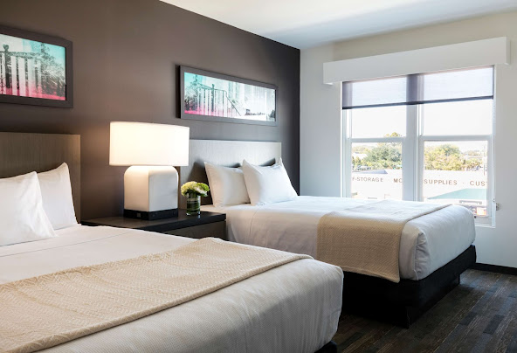](https://www.google.com/travel/search?q=Hyatt+House+Charleston/Historic+District&qs=MhNDZ29JdGRqOTN1emR4YUExRUFF&ts=CAESCAoCCAMKAggDGhYSFBISCgcI6Q8QChgbEgcI6Q8QCxgBKgcKBToDVVNE" \t "_blank)

[Hyatt House Charleston/Historic District4.2 (1947) • 3-star hotel](https://www.google.com/travel/search?q=Hyatt+House+Charleston/Historic+District&qs=MhNDZ29JdGRqOTN1emR4YUExRUFF&ts=CAESCAoCCAMKAggDGhYSFBISCgcI6Q8QChgbEgcI6Q8QCxgBKgcKBToDVVNE" \t "_blank)

[$246/night](https://www.google.com/travel/search?q=Hyatt+House+Charleston/Historic+District&qs=MhNDZ29JdGRqOTN1emR4YUExRUFF&ts=CAESCAoCCAMKAggDGhYSFBISCgcI6Q8QChgbEgcI6Q8QCxgBKgcKBToDVVNE" \t "_blank)

[Modern rooms, studios & suites in a low-key hotel featuring a bar, an indoor pool & free breakfast.](https://www.google.com/travel/search?q=Hyatt+House+Charleston/Historic+District&qs=MhNDZ29JdGRqOTN1emR4YUExRUFF&ts=CAESCAoCCAMKAggDGhYSFBISCgcI6Q8QChgbEgcI6Q8QCxgBKgcKBToDVVNE" \t "_blank)

Tennessee, USA

I would assume that staying at a motel on King Street with free parking with be a better alternative, then a Hotel along the beach during off season?

That's a very insightful question. The "better alternative" really depends on your priorities for the trip. You're right that a hotel on King Street with free parking could be an excellent option, especially during the off-season.

Here's a breakdown to help you decide which option might be best for you and your companion:

### **Staying on King Street with Free Parking**

**Pros:**

**Convenience for Antique Hunting:** King Street is the heart of the antique district. Staying here would put you within easy walking distance of most of the shops, which could be a huge plus for you. It would eliminate the need to drive, search for parking, or pay for it every time you want to go antiquing.

**Evening Entertainment & Dining:** You'll be right in the middle of Charleston's best restaurants and nightlife, making it easy to enjoy a nice dinner without worrying about driving or parking.

**Cost Savings on Parking:** The free parking you've identified is a major benefit. Given that daily garage parking in this area can cost up to $24, a free parking spot for five days could save you over $100.

**Cons:**

**Commute to the Beach:** To get to the ocean, you would need to drive a significant distance (20-30 minutes, depending on traffic and the beach you choose). This might be a minor inconvenience if you only plan to have one beach day, but it could be a drawback if you hoped to see the ocean more frequently.

### **Staying at a Hotel on the Beach**

**Pros:**

**Unbeatable Access to the Ocean:** Waking up and being able to walk right out to the beach is a huge advantage. If your dream is to spend a lot of time by the water, this is the superior option.

**More Relaxing Pace:** The beach areas, especially in the off-season, can be very peaceful. You'll have a more laid-back atmosphere away from the hustle and bustle of downtown.

**Easier Parking:** Off-season parking at the beaches is much more reasonable and sometimes even free, so you'll save money there compared to downtown.

**Cons:**

**Commute to King Street:** Just as with the first option, you'd have to drive 20-30 minutes to get to the antique shops and restaurants on King Street. The cost of daily parking in a downtown garage would be an added expense.

**Less Variety in Dining/Entertainment:** While the beaches have great local restaurants, the variety of dining and entertainment options isn't as extensive as in the historic downtown area.

**Conclusion**

Given that your interests are split between antique hunting and the ocean, and considering the cost savings, **staying at a motel on King Street with free parking would likely be the better alternative.** The convenience and cost-saving on parking for your primary antique-hunting interest, coupled with the ease of visiting the many downtown restaurants and attractions, seem to outweigh the single commute you'd have to make to the beach. You can easily dedicate an entire day to driving to one of the beaches you're interested in, parking for a minimal fee, and enjoying the ocean.

Could you give this conversation to me in a pdf format?

I can't create and send you a PDF file. However, I can provide the complete conversation in a structured format that you can easily copy and paste into a document on your computer. From there, you can save or export it as a PDF.

Would you like me to present the conversation in a clear, easy-to-copy text format?